Build a Serverless Lead Capture on AWS

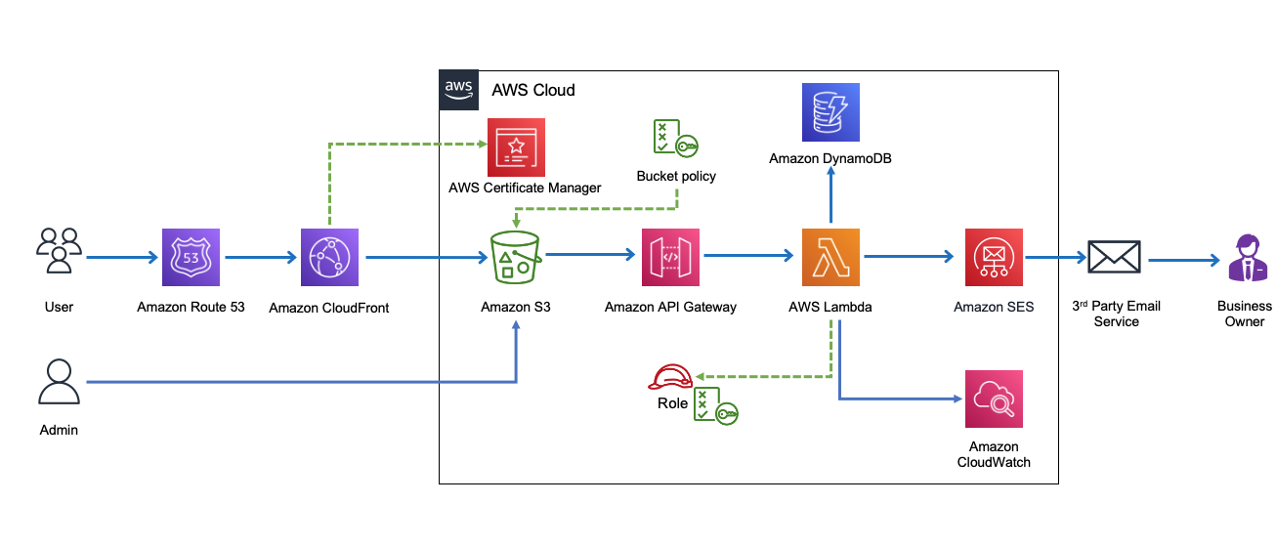

Phase 1: Hosting Static Website
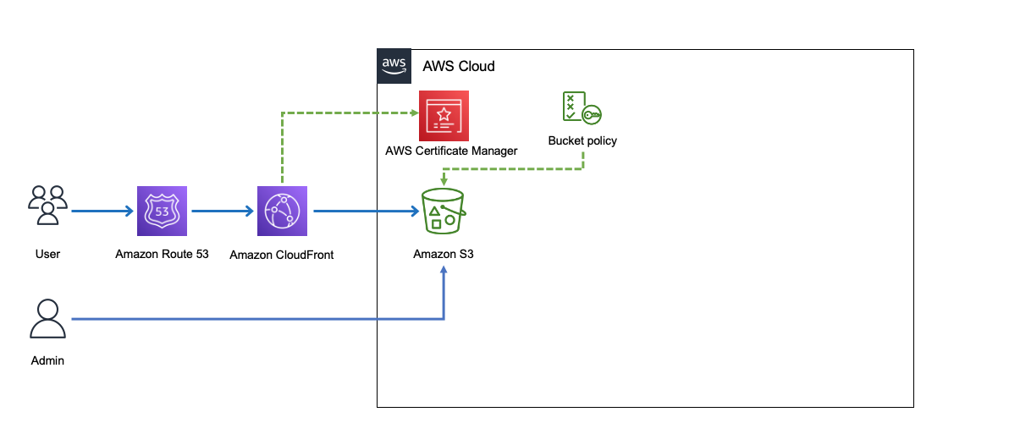

STEP 1: Download website
You can clone project form my Github:
git clone https://github.com/pravinmishraaws/Ebook.git

STEP 2: Locate the downloaded file in your terminal
ls

STEP 3: Create Amazon S3 bucket
aws s3 ls
aws s3 mb s3://epicreads

STEP 4: Edit static website hosting
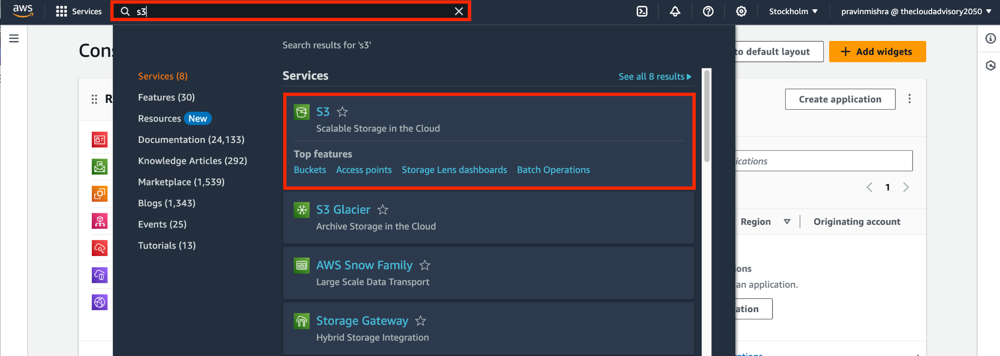

STEP 5: Edit bucket settings

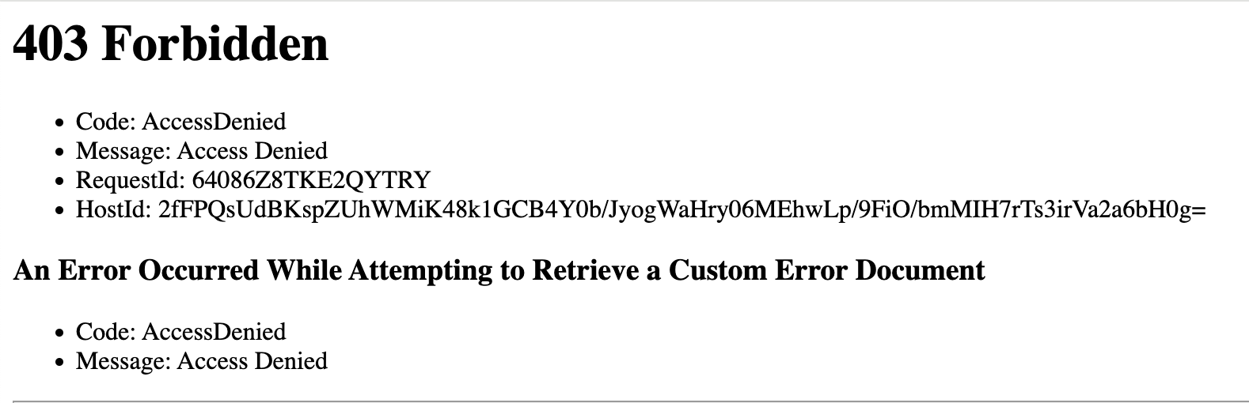

STEP 6: Add Bucket policy

Note: Multi Level of protection.

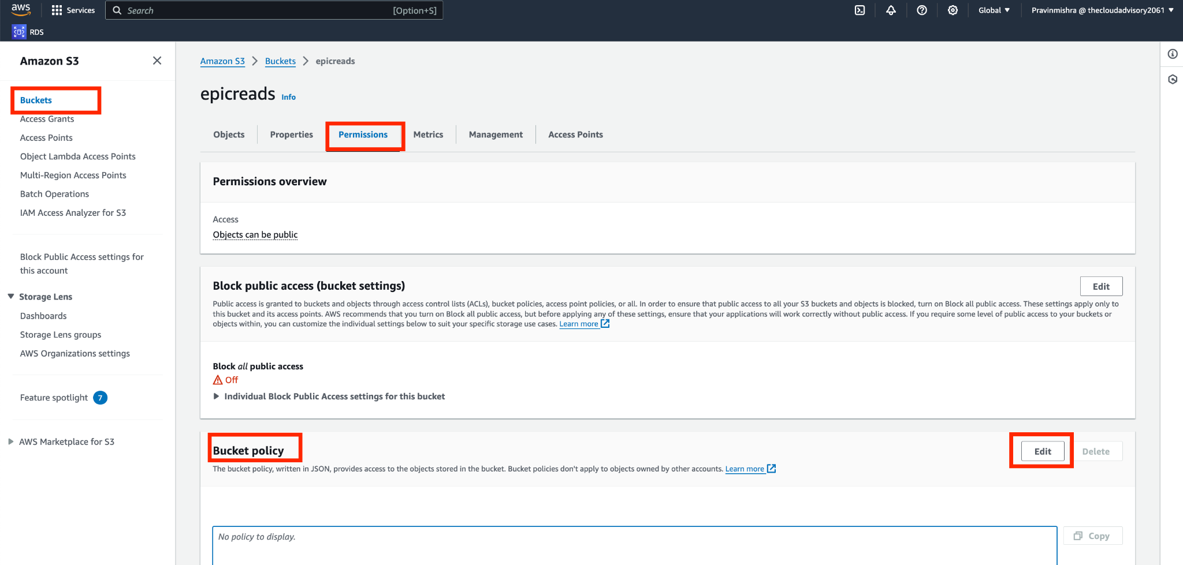

{
"Version": "2012-10-17",
"Statement": [
{
"Sid": "PublicReadGetObject",
"Effect": "Allow",
"Principal": "*",
"Action": [
"s3:GetObject"
],
"Resource": [
"arn:aws:s3:::Bucket-Name/*"
]
}
]
}
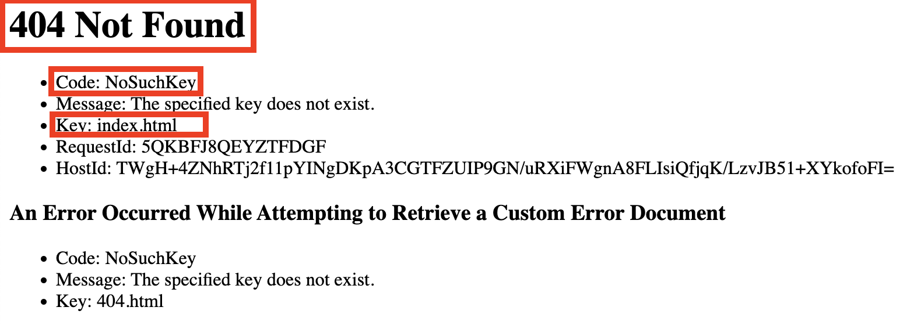

STEP 7: Display error page

vi 404.html

Hi I am an error page!
Sorry, I will be back soon!
aws s3 cp 404.html s3://epicreads

STEP 8: Sync the files to S3 bucket

aws s3 sync . s3://epicreads

STEP 9: Refresh the browser

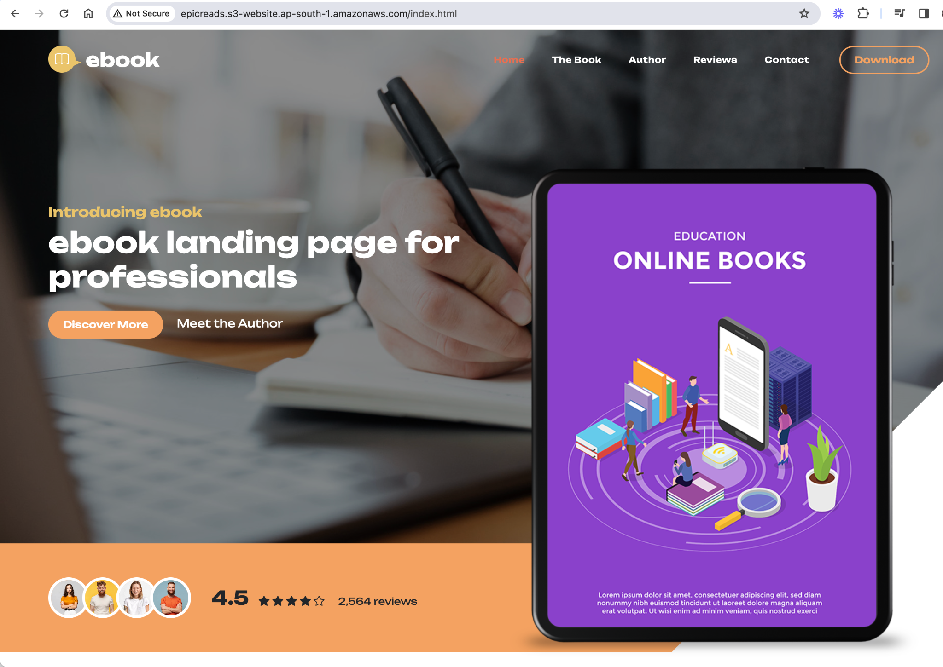

STEP 10: Public Certificate (us east)

STEP 11: Configure CloudFront (global)

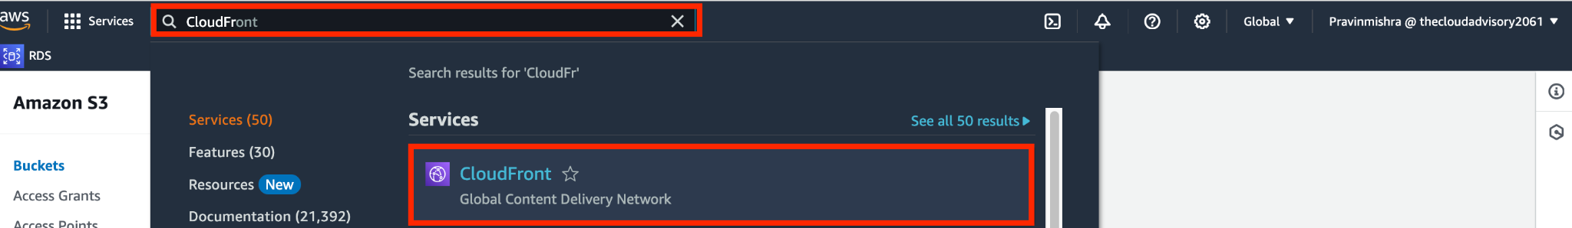
Congrats you have successfully completed Project 9!

STEP 12: Configure Route 53

Phase 2: Implementing a Dynamic 'Contact Us'

STEP 1: Understand the architecture
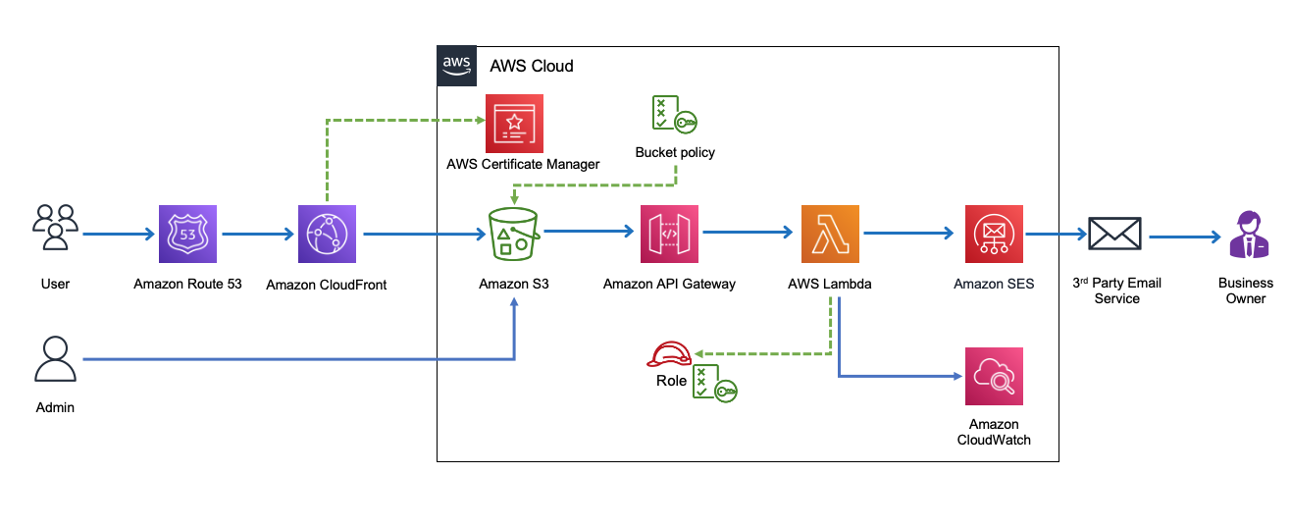

STEP 2: Understand the structure of ‘Contact Us’ Form

STEP 3: Setup Amazon SES

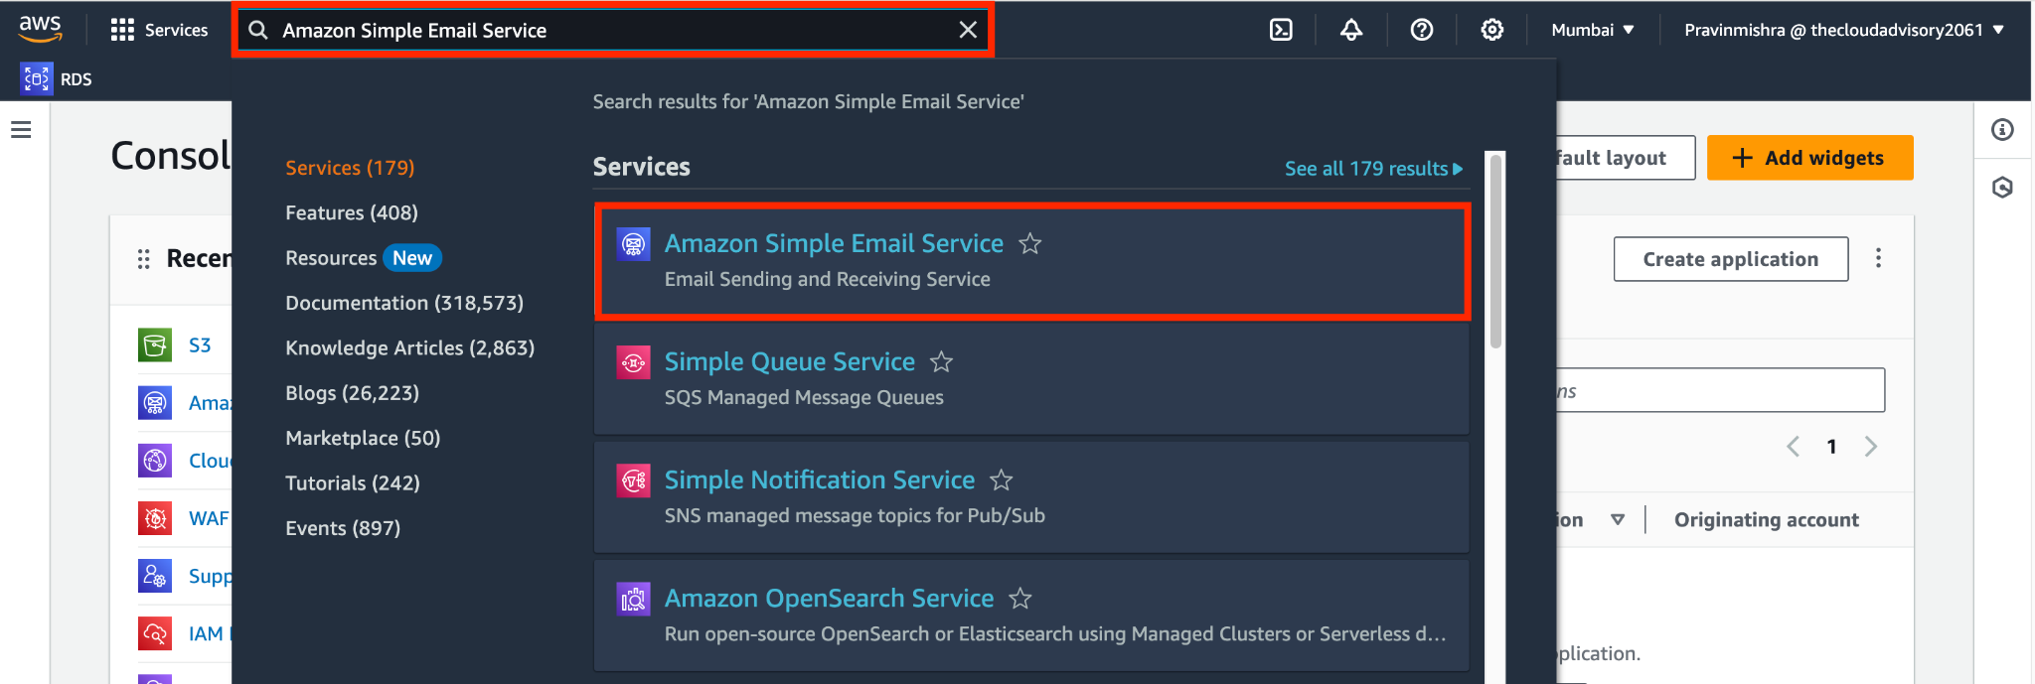

STEP 4: Create IAM Policy

{
"Version": "2012-10-17",
"Statement": [
{
"Sid": "CloudWatchLogsBasic",
"Effect": "Allow",
"Action": ["logs:CreateLogGroup"],
"Resource": "*"
},
{
"Sid": "CloudWatchLogsStreamEvents",
"Effect": "Allow",
"Action": ["logs:CreateLogStream","logs:PutLogEvents"],
"Resource": "*"
},
{
"Sid": "AllowSesSendEmail",
"Effect": "Allow",
"Action": ["ses:SendEmail","ses:SendRawEmail"],
"Resource": "*"
}
]
}

Policy Name:

Epicreads_SES_policy

STEP 5: Create IAM Role

Epicreads_role

STEP 6: Understand AWS Lambda Function

STEP 7: Create Lambda Function

epicreads_contactus
Lambda Code:

import { SESClient, SendEmailCommand } from "@aws-sdk/client-ses";

const ses = new SESClient({ region: "us-east-1" });

const RECEIVER = "hello@pravinmishra.in";
const SENDER = "mail@pravinmishra.in";

export const handler = async (event) => {
console.log("Received event:", event);

const params = {
Destination: { ToAddresses: [RECEIVER] },
Message: {
Body: {
Text: {
Data: `Full Name: ${event.name}
Phone: ${event.phone}
Email: ${event.email}
Message: ${event.message}`,
Charset: "UTF-8",
},
},
Subject: { Data: `Website Query Form: ${event.name}`, Charset: "UTF-8" },
},
Source: SENDER,
};

await ses.send(new SendEmailCommand(params));

return {
statusCode: 200,
headers: {
"Content-Type": "application/json",
"Access-Control-Allow-Origin": "*",
},
body: JSON.stringify({ result: "Success" }),
};
};

STEP 8: Test the function in the console
Name the event as "TestEvent.

STEP 9: Build an API
Understanding APIs

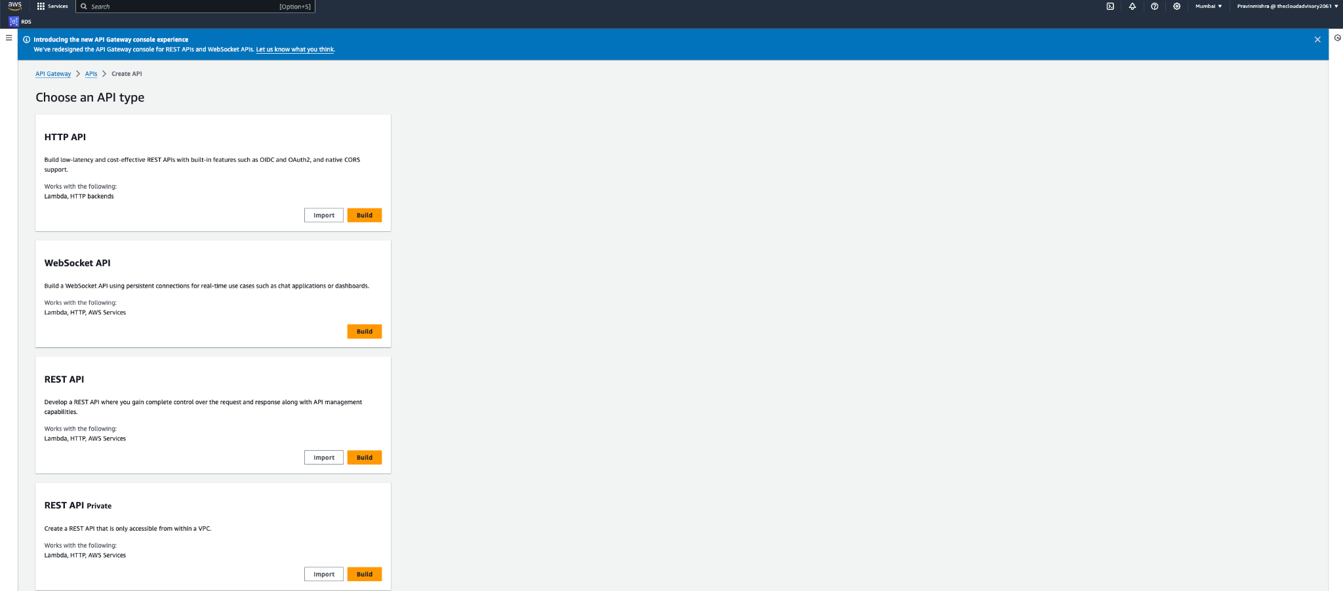

HTTP API:

- This type of API is designed for building low-latency and cost-effective RESTful APIs (Representational State Transfer) for web applications.
- It comes with built-in features like OIDC (OpenID Connect) and OAuth2 for handling authentication and authorization.
- It also has native CORS (Cross-Origin Resource Sharing) support, which allows web applications running at one origin to request resources from another origin securely.
- It works seamlessly with AWS Lambda functions and HTTP backends, making it easy to integrate with your serverless or traditional backend services.

WebSocket API:

- WebSocket APIs are used for building real-time communication applications like chat applications, online gaming, or dashboards that require persistent and bidirectional connections.
- These APIs are designed for handling WebSocket connections, enabling real-time data exchange between clients and servers.
- WebSocket APIs can work with various backend services, including AWS Lambda functions, HTTP endpoints, and AWS services, allowing you to build interactive and responsive applications.

REST API:

- REST APIs are a standard way to develop web services following the principles of Representational State Transfer (REST).
- With a REST API, you have complete control over the request and response structure, making it highly customizable to suit your application's needs.
- REST APIs can be integrated with various backend services, including AWS Lambda functions, HTTP endpoints, and AWS services, giving you flexibility in designing and managing your APIs.

REST API Private:

- This is a variation of a REST API designed to be accessible only from within an Amazon Virtual Private Cloud (VPC).
- It provides an extra layer of security by ensuring that the API is isolated from the public internet and can only be accessed by resources within your VPC.
- Like the standard REST API, it can also work with various backend services, including AWS Lambda functions, HTTP endpoints, and AWS services.

1. Create an API

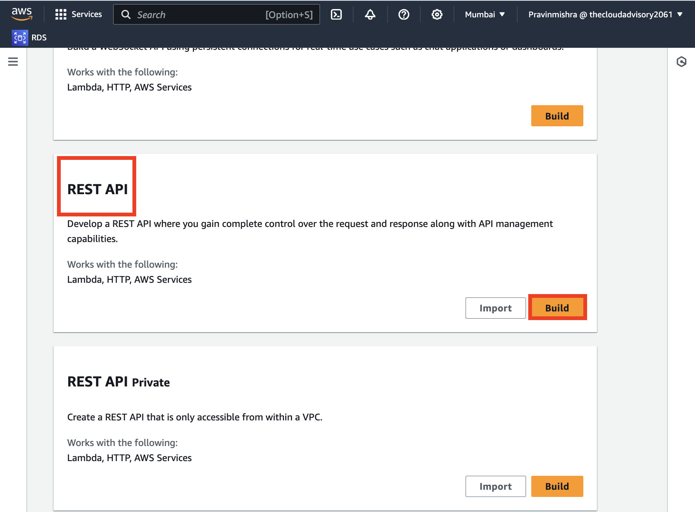

API name EpicReads_api

2. Create Resource

Resource Name epicreads_resource

3. Create Method

Choose Post for Method type.

STEP 10: Enable CORS

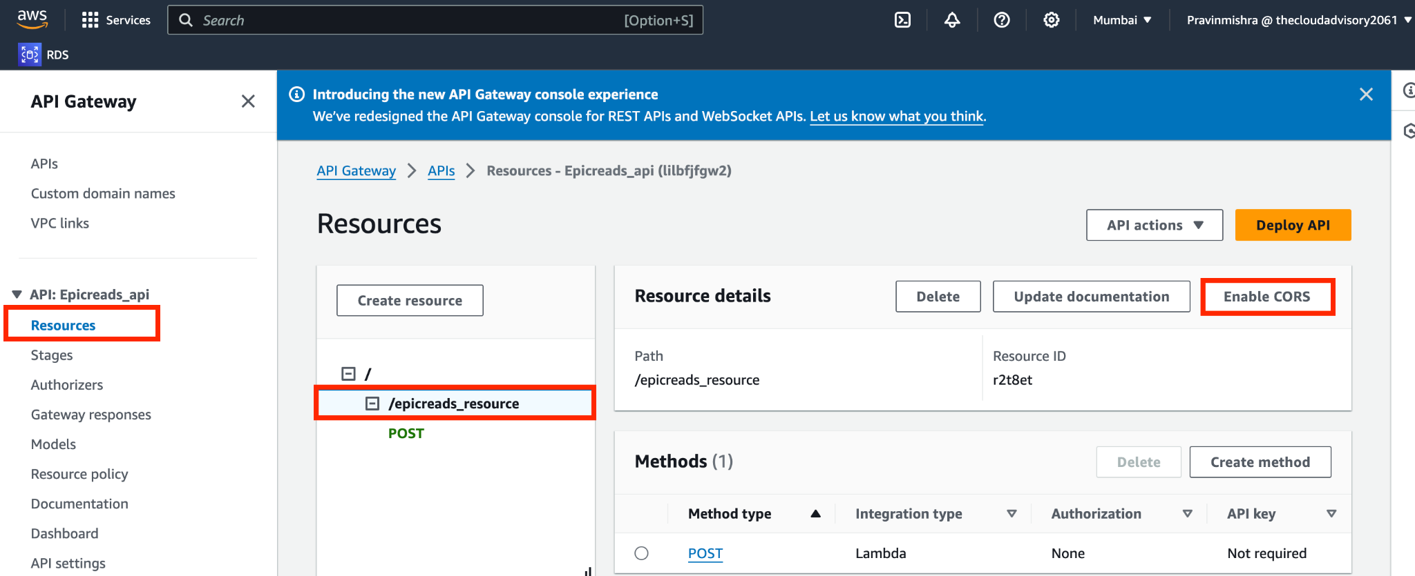

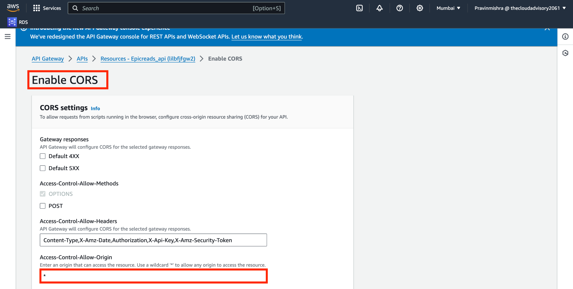

STEP 11: Deploy API

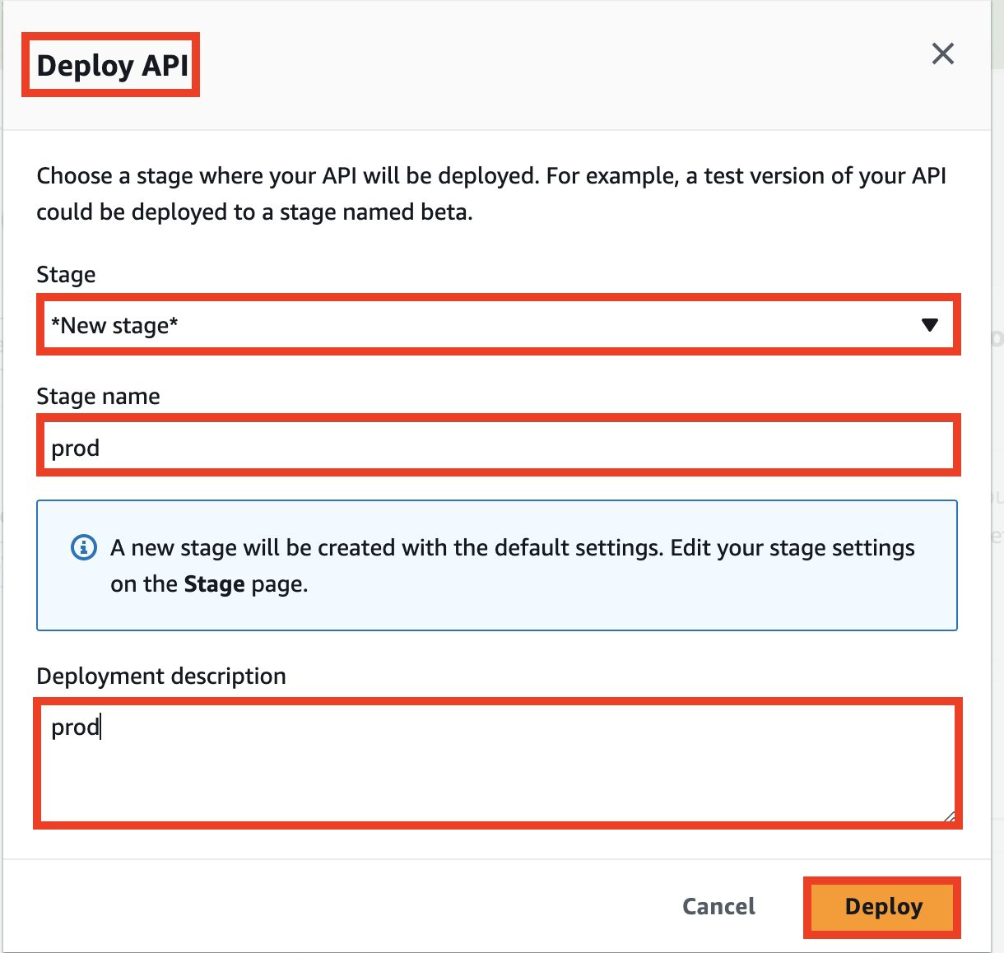

STEP 12: Test API with CURL

1) Preflight (OPTIONS) — simulate the browser check
curl -i -X OPTIONS "https://rpl7fhoig9.execute-api.us-east-1.amazonaws.com/dev/epicreads_resource" \
-H "Origin: https://your-site-domain.com" \
-H "Access-Control-Request-Method: POST" \
-H "Access-Control-Request-Headers: Content-Type,Authorization,X-Api-Key"

You should see 200 and headers like:
Access-Control-Allow-Origin, Access-Control-Allow-Methods, Access-Control-Allow-Headers.

2) Actual POST request (JSON body)
curl -i -X POST "https://rpl7fhoig9.execute-api.us-east-1.amazonaws.com/dev/epicreads_resource" \
-H "Origin: https://your-site-domain.com" \
-H "Content-Type: application/json" \
-d '{
"name": "Pravin Mishra",
"phone": "+358-555-1234",
"email": "user@example.com",
"message": "Hello from curl"
}'

STEP 13: Update Website

Update the form with below inside the index.htnl:
<form id="contact-form" class="custom-form ebook-download-form bg-white shadow" role="form">

Javascript:
<script>
(function () {
const URL = "https://j5onc24oq0.execute-api.eu-north-1.amazonaws.com/dev/epicreads_resource";

const form = document.getElementById('contact-form');
if (!form) {
console.error("contact-form not found in DOM");
return;
}

form.addEventListener('submit', async function (e) {
e.preventDefault();

const name = document.getElementById('ebook-form-name')?.value || "";
const email = document.getElementById('ebook-email')?.value || "";
const messageEl = document.getElementById('ebook-message'); // optional field
const message = messageEl ? messageEl.value : "";

try {
const resp = await fetch(URL, {
method: 'POST',
headers: { 'Content-Type': 'application/json', 'Accept': 'application/json' },
body: JSON.stringify({ name, email, message }),
// mode: 'cors' // not required, but harmless if you want to make it explicit
});

const contentType = resp.headers.get('content-type') || '';
let bodyText = '';
try { bodyText = await resp.text(); } catch { }

console.log('API status:', resp.status);
console.log('API headers:', Object.fromEntries(resp.headers.entries()));
console.log('API body:', bodyText);

if (!resp.ok) {
throw new Error(`HTTP ${resp.status} - ${bodyText || 'No body'}`);
}

alert("✅ Thanks for contacting us, we will get back to you soon!");
this.reset();
} catch (err) {
console.error("Request failed:", err);
alert("❌ Something went wrong. Please try again.");
}
});
})();
</script>

STEP 14: Test Locally
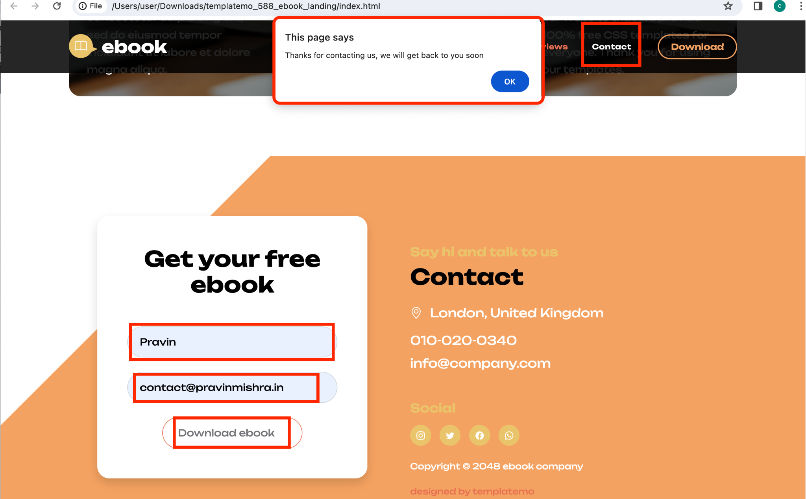

STEP 15: Upload new changes to S3 & Test

aws s3 sync . s3://epicreads

STEP 16: Test with domain name

STEP 17: Verify CloudWatch Log

Phase 3: Data Management for 'Contact Us'


STEP 1: Create a table

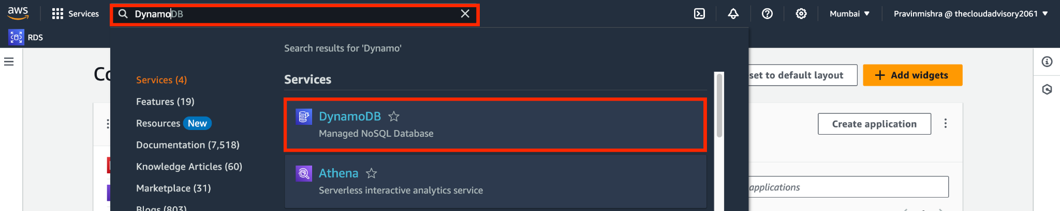

Figure 12.1: Navigate to DynamoDB
Table name, enter ContactMessages.
For the Partition key name, enter id.
For the Partition key type, choose String.
Create the table (one-time) with AWS CLI
aws dynamodb create-table \
--table-name ContactMessages \
--attribute-definitions AttributeName=id,AttributeType=S \
--key-schema AttributeName=id,KeyType=HASH \
--billing-mode PAY_PER_REQUEST \
--region us-east-1

STEP 2: Update Lambda Role Permission

Create Inline Policy (LambdaContact-DdbWrite)

{
"Version": "2012-10-17",
"Statement": [
{ "Effect": "Allow",
"Action": ["dynamodb:PutItem"],
"Resource": "*" }
]
}

STEP 3: Update the Lambda function code

Use below updated Lambda code that writes to DynamoDB and still sends the email via SES.

import { SESClient, SendEmailCommand } from "@aws-sdk/client-ses";
import { DynamoDBClient } from "@aws-sdk/client-dynamodb";
import { DynamoDBDocumentClient, PutCommand } from "@aws-sdk/lib-dynamodb";
import { randomUUID } from "crypto";

const REGION = process.env.AWS_REGION || "us-east-1"; // keep SES & DDB in same region
const TABLE_NAME = process.env.TABLE_NAME || "ContactMessages";

const RECEIVER = "hello@pravinmishra.in";
const SENDER = "mail@pravinmishra.in";

const ses = new SESClient({ region: REGION });
const ddb = DynamoDBDocumentClient.from(new DynamoDBClient({ region: REGION }));

const EMAIL_RE = /^[^\s@]+@[^\s@]+\.[^\s@]+$/;

export const handler = async (event) => {
console.log("Received event:", JSON.stringify(event));

try {
const body =
typeof event?.body === "string" ? JSON.parse(event.body) :
(event?.body ?? event ?? {});

const { name = "", phone = "", email = "", message = "" } = body;

if (!name || !email) {
return {
statusCode: 400,
headers: corsHeaders(),
body: JSON.stringify({ error: "name and email are required" })
};
}

const id = randomUUID();
const ts = new Date().toISOString();

// 1) Save to DynamoDB
await ddb.send(new PutCommand({
TableName: TABLE_NAME,
Item: { id, name, phone, email, message, createdAt: ts }
}));

// 2) Send email via SES (only add Reply-To if valid)
const params = {
Destination: { ToAddresses: [RECEIVER] },
Message: {
Subject: { Data: `Website Query Form: ${name}`, Charset: "UTF-8" },
Body: {
Text: {
Data:
`Full Name: ${name}
Phone: ${phone}
Email: ${email}
Message: ${message}
ID: ${id}
Time: ${ts}`,
Charset: "UTF-8"
}
}
},
Source: SENDER
};

if (EMAIL_RE.test(email)) {
params.ReplyToAddresses = [email];
}

await ses.send(new SendEmailCommand(params));

return {
statusCode: 200,
headers: corsHeaders(),
body: JSON.stringify({ ok: true, id })
};
} catch (err) {
console.error("Error:", err);
return {
statusCode: 500,
headers: corsHeaders(),
body: JSON.stringify({ error: "Internal error" })
};
}
};

function corsHeaders() {
return {
"Content-Type": "application/json",
"Access-Control-Allow-Origin": "*",
"Access-Control-Allow-Methods": "OPTIONS,POST",
"Access-Control-Allow-Headers":
"Content-Type,Authorization,X-Api-Key,X-Amz-Date,X-Amz-Security-Token"
};
}

Reminders:
- Your role needs dynamodb:PutItem (you said you’ll add an inline policy—perfect).
- Create the table ContactMessages with hash key id (or set TABLE_NAME to your table).

STEP 4: Deploy and Test

Verify data in DynamoDB

STEP 5: Test from the browser

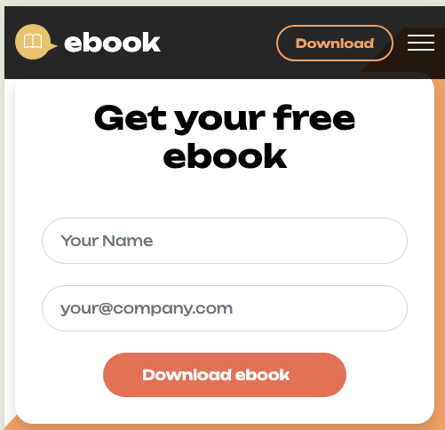

Task 4: Clean Up!

